11.2 Intermolecular Forces
The strengths of intermolecular forces of different substances vary over a wide range. However, they are generally much weaker than ionic or covalent bonds (Figure 11.2). For example, only 16 kJ/mol is required to overcome the intermolecular attractions between HCl molecules in liquid HCl in order to vaporize it. In contrast, the energy required to break the covalent bond to dissociate HCl into H and Cl atoms is 431 kJ/mol. Less energy is required to vaporize a liquid or to melt a solid than to break covalent bonds in molecules. Thus, when a molecular substance like HCl changes from solid to liquid to gas, the molecules themselves remain intact.
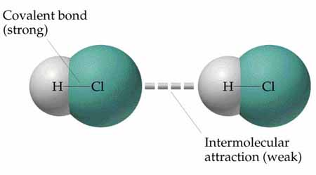
Many properties of liquids, including their boiling points, reflect the strengths of the intermolecular forces. A liquid boils when bubbles of its vapor form within the liquid. The molecules of a liquid must overcome their attractive forces in order to separate and form a vapor. The stronger the attractive forces, the higher is the temperature at which the liquid boils. Similarly, the melting points of solids increase with an increase in the strengths of the intermolecular forces.
Three types of intermolecular attractive forces are known to exist between neutral molecules: dipole-dipole forces, Van der Walls forces, and hydrogen-bonding forces. Another kind of attractive force, the ion-dipole force, is important in solutions. As a group, intermolecular forces tend to be less than 15 percent as strong as covalent or ionic bonds. As we consider these forces, notice that each is electrostatic in nature, involving attractions between positive and negative species.

Dipole-Dipole Forces
A dipole-dipole force exists between polar molecules. Polar molecules attract each other when the positive end of one molecule is near the negative end of another, as in Figure 11.4(a). Dipole-dipole forces are effective only when polar molecules are very close together, and they are generally weaker than ion-dipole forces.
When we examine various liquids, we find that for molecules of approximately equal mass and size, the strengths of intermolecular attractions increase with increasing polarity.

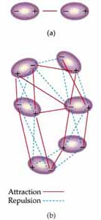
Figure 11.4 (a) The electrostatic interaction of two polar molecules. (b) The interaction of many dipoles in a condensed state.

Van de Walls Forces
What kind of interparticle forces can exist between nonpolar atoms or molecules? Clearly, there can be no dipole-dipole forces when the particles are nonpolar. Yet the fact that nonpolar gases can be liquefied tells us that there must be some kind of attractive interactions between the particles. The origin of this attraction was first proposed in 1930 by Fritz London, a German-American physicist. London recognized that the motion of electrons in an atom or molecule can create an instantaneous dipole moment. Let's consider helium atoms as an example.
In a collection of helium atoms the average distribution of the electrons about each nucleus is spherically symmetrical. The atoms are nonpolar and possess no permanent dipole moment. The instantaneous distribution of the electrons, however, can be different from the average distribution. For example, if we could freeze the motion of the electrons in a helium atom at any given instant, both electrons could be on one side of the nucleus. At just that instant, then, the atom would have an instantaneous dipole moment.
Because electrons repel one another, the motions of electrons on one atom influence the motions of electrons on its near neighbours. Thus, the temporary dipole on one atom can induce a similar dipole on an adjacent atom, causing the atoms to be attracted to each other as shown in Figure 11.5. 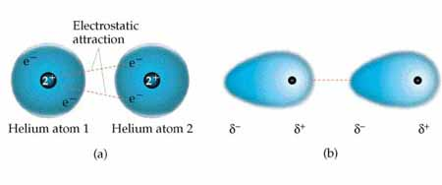
Figure 11.5 Two schematic representations of the instantaneous dipoles on two adjacent helium atoms, showing the electrostatic attraction between them.
The ease with which the charge distribution in a molecule can be distorted by an external electric field is called its polarizability. We can think of the polarizability of a molecule as a measure of the "squashiness" of its electron cloud; the greater the polarizability of a molecule, the more easily its electron cloud can be distorted to give a momentary dipole. Therefore, more polarizable molecules have stronger Van der Walls forces. In general, larger molecules tend to have greater polarizabilities because they have a greater number of electrons and their electrons are farther from the nuclei. Therefore, the strength of the Van de Walls forces tends to increase with increasing molecular size. Because molecular size and mass generally parallel each other, Van der Walls forces tend to increase in strength with increasing molecular weight. Thus, the boiling points of the halogens and the noble gases increase with increasing molecular weight (Table 11.3).
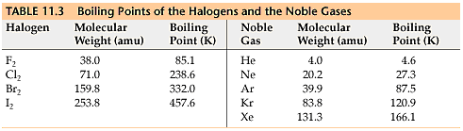
The shapes of molecules can also play a role in the magnitudes of Van der Walls forces. For example, n-pentane and neopentane, illustrated in Figure 11.6, have the same molecular formula, C₅H₁₂, yet the boiling point of n-pentane is 27 K higher than that of neopentane. (The n in n-pentane is an abbreviation for the word normal. A normal hydrocarbon is one in which carbon atoms are arranged in a straight chain.) The difference can be traced to the different shapes of the two molecules. The overall attraction between molecules is greater in the case of n-pentane because the molecules can come in contact over the entire length of the long, somewhat cylindrically shaped molecule. Less contact is possible between the more compact and nearly spherical molecules of neopentane.
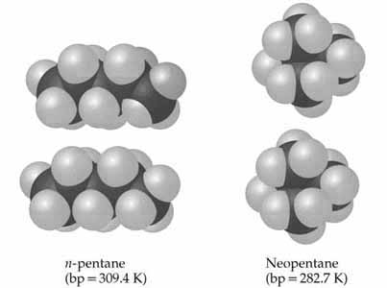
Figure 11.6 Molecular shape affects intermolecular attraction. The n-pentane molecules make more contact with each other than do the neopentane molecules. Thus, n-pentane has the greater intermolecular attractive forces and therefore has the higher boiling point (bp).
which we consider after the next Sample Exercise.

Hydrogen Bonding
Figure 11.7 shows the boiling points of the simple hydrogen compounds of group 4A and 6A elements. In general, the boiling point increases with increasing molecular weight, owing to increased Van der Walls forces. The notable exception to this trend is H₂O, whose boiling point is much higher than we would expect on the basis of its molecular weight. The compounds NH₃ and HF also have abnormally high boiling points. These compounds also have many other characteristics that distinguish them from other substances of similar molecular weight and polarity. For example, water has a high melting point, a high specific heat, and a high heat of vaporization. Each of these properties indicates that the intermolecular forces between H₂O molecules are abnormally strong.
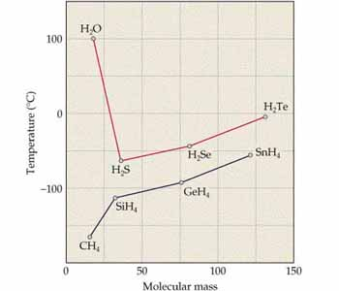
Figure 11.7 Boiling points of the group 4A (bottom) and 6A (top) hydrides as a function of molecular weight.
These strong intermolecular attractions in H₂O result from hydrogen bonding. Hydrogen bonding is a special type of intermolecular attraction that exists between the hydrogen atom in a polar bond (particularly an H F, H O, or H N bond) and an unshared electron pair on a nearby small electronegative ion or atom (usually an F, O, or N atom on another molecule). For example, a hydrogen bond exists between the H atom in an HF molecule and the F atom of an adjacent HF molecule, F H F H (where the dots represent the hydrogen bond between the molecules). Several additional examples are shown in Figure 11.8.
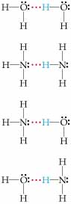
Figure 11.8 Examples of hydrogen bonding. The solid lines represent covalent bonds; the red dotted lines represent hydrogen bonds.
Hydrogen bonds can be considered unique dipole-dipole attractions. Because F, N, and O are so electronegative, a bond between hydrogen and any of these three elements is quite polar, with hydrogen at the positive end:
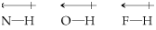
The hydrogen atom has no inner core of electrons. Thus, the positive side of the bond dipole has the concentrated charge of the partially exposed, nearly bare proton of the hydrogen nucleus. This positive charge is attracted to the negative charge of an electronegative atom in a nearby molecule. Because the electron-poor hydrogen is so small, it can approach an electronegative atom very closely and thus interact strongly with it.
The energies of hydrogen bonds vary from about 4 kJ/mol to 25 kJ/mol. Hydrogen bonds are generally stronger than dipole-dipole or Van der Walls forces, they play important roles in many chemical systems, including those of biological significance.

Comparing Intermolecular Forces
Let's put the intermolecular forces in perspective. To summarize, we can identify the intermolecular forces that are operative in a substance by considering its composition and structure. Van der Walls forces are found in all substances. The strengths of these forces increase with increased molecular weight and also depend on molecular shapes. Dipole-dipole forces are stronger than Van der Walls forces and are found in polar molecules. Hydrogen bonds, which are recognized by the presence of H atoms bonded to F, O, or N, also add to the effect of dispersion forces. Hydrogen bonds tend to be the strongest type of intermolecular force. None of these intermolecular forces, however, is as strong as ordinary ionic or covalent bonds. Figure 11.12 presents a systematic way of identifying the kinds of intermolecular forces in a particular system, including ion-dipole and ion-ion forces.
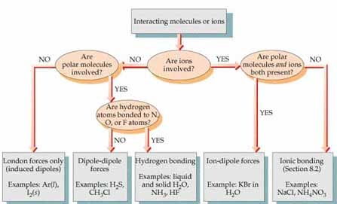
11.12 The strengths of the forces generally increase proceeding from left to right.

SAMPLE EXERCISE 11.3
List the substances BaCl₂, H₂, CO, HF, and Ne in order of increasing boiling points.
SOLUTION The boiling point depends in part on the attractive forces in the liquid. These are stronger for ionic substances than for molecular ones, so BaCl₂ has the highest boiling point. The intermolecular forces of the remaining substances depend on molecular weight, polarity, and hydrogen bonding. The other molecular weights are H₂ (2), CO (28), HF (20), and Ne (20). The boiling point of H₂ should be the lowest because it is nonpolar and has the lowest molecular weight. The molecular weights of CO, HF, and Ne are roughly the same. Because HF can hydrogen bond, it has the highest boiling point of the three. Next is CO, which is slightly polar and has the highest molecular weight. Finally, Ne, which is nonpolar, should have the lowest boiling point of these three. The predicted order of boiling points are therefore
The actual normal boiling points are H₂ (20 K), Ne (27 K), CO (83 K), HF (293 K), and BaCl₂ (1813 K), in agreement with our predictions.

