Mandatory Experiment 6.1

Monitoring the rate of production of oxygen from hydrogen peroxide using manganese dioxide as a catalyst

Student Material

Theory

Hydrogen peroxide decomposes into water and oxygen as follows:

H₂O_{2(l)} → H₂O_{(l)} + ¹/₂ O_{2(g)}

This occurs much too slowly to be monitored. However, manganese dioxide acts as a suitable catalyst, and the reaction occurs at a measurable rate.

Method 1 – using an inverted graduated cylinder

Chemicals and Apparatus
Hydrogen peroxide (20 volumes)  
Powdered manganese(IV) oxide _{n}

100 cm³ graduated cylinder
Beehive shelf
Large trough
Conical flask with suitable stopper and delivery tube
Stop-clock
Small test tube
Thread
Teat pipette

Procedure

NB: Wear your safety glasses.

- Measure out 5 cm³ of hydrogen peroxide and dilute to 50 cm³ with water. Place it in the conical flask.

- Weigh about 0.5 g manganese(IV) oxide into the small test tube, and use the thread and stopper to suspend the test tube in the conical flask. Avoid contact between the manganese(IV) oxide and the hydrogen peroxide.

- Place sufficient water in the trough to allow the graduated cylinder to be filled with water and inverted over the beehive shelf. Using a teat pipette, inject air into the graduated cylinder until the water level is at the 10 cm³ mark.

- Arrange the delivery tube for the oxygen produced to be collected in the graduated cylinder by displacement of water.

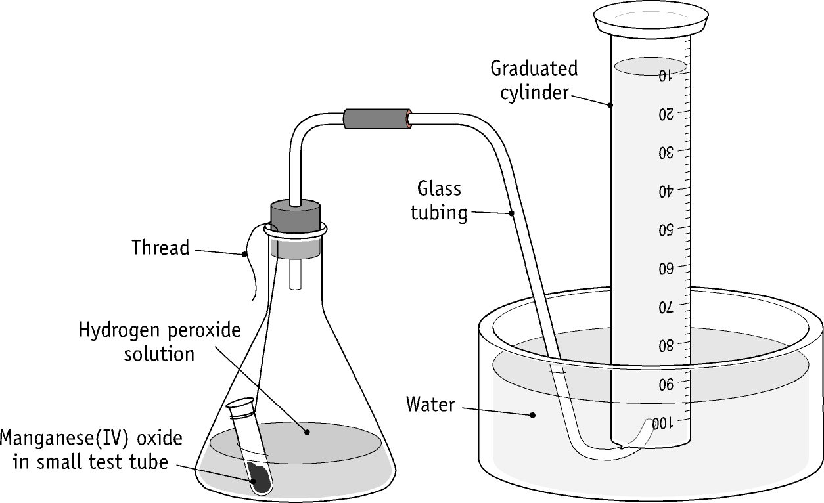

- Loosen the stopper momentarily to allow the thread to fall into the flask and shake vigorously, thus bringing the manganese(IV) oxide into contact with the hydrogen peroxide. The stop-clock should be started as this contact is made. Record the total volume of gas in the graduated cylinder every 30 seconds. Readings should be taken at eye level.

- Present the results in the following table:

Time (min) | Total volume of gas (cm³) | Total volume of oxygen(cm³)

- Draw a graph of total volume of oxygen against time, putting time on the horizontal axis.

Questions relating to the experiments

- Why is the slope of the graph steepest in the early stages of the reaction?

- At what stage is the reaction complete?

- What would be the effect on the graph of doubling the amount of manganese(IV) oxide?

- Would doubling the manganese(IV) oxide create a practical difficulty? Explain your answer.

- What would be the effect on the graph of doubling the concentration of hydrogen peroxide?

- Would doubling the concentration of hydrogen peroxide create a practical difficulty? Explain your answer.

Specimen Results – Method 1

Time (s) | Total volume of gas (cm³) | Total volume of oxygen(cm³)
0 | 10 | 0
60 | 31 | 21
120 | 42 | 32
180 | 50 | 40
240 | 55 | 45
300 | 60 | 50
360 | 65 | 55
420 | 68 | 58
480 | 70 | 60
540 | 73 | 63
600 | 75 | 65
660 | 78 | 68
720 | 80 | 70
780 | 81.5 | 71.5
840 | 83 | 73
900 | 85 | 75
960 | 86.5 | 76.5
1020 | 88 | 78
1080 | 89 | 79
1140 | 90 | 80
1200 | 91.5 | 81.5
1260 | 93 | 83
1320 | 94 | 84
1380 | 95 | 85
1440 | 95 | 85
1500 | 95 | 85
1560 | 95 | 85
1620 | 95 | 85
1680 | 95 | 85

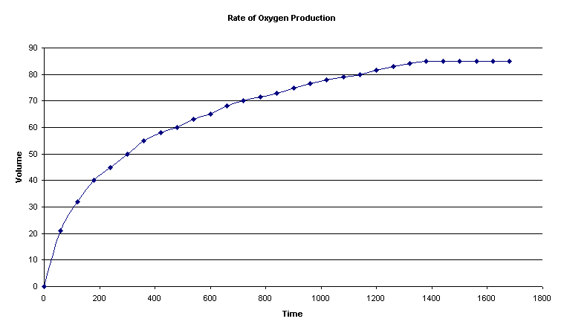

Suggested Answers to Student Questions

- Why is the slope of the graph steepest in the early stages of the reaction?

Since rate is proportional to concentration, the greatest rate, indicated by the
steepest slope, is evident in the early stages when the concentration of hydrogen
peroxide is at a maximum.

- At what stage is the reaction complete?

When the graph becomes horizontal.

- What would be the effect on the graph of doubling the amount of
manganese(IV) oxide?

The increased surface area of catalyst would speed up the reaction, giving a
steeper slope and an earlier completion. The volume of oxygen produced would
be unchanged.

- Would doubling the manganese(IV) oxide create a practical difficulty? Explain
your answer.

Yes. The production of oxygen could become too quick for accurate monitoring.

- What would be the effect on the graph of doubling the concentration of
hydrogen peroxide?

Increasing the concentration of a reactant would speed up the rate, as indicated
by a steeper slope. Doubling the concentration would produce double the final
volume of oxygen.

- Would doubling the concentration of hydrogen peroxide create a practical
difficulty? Explain your answer.

Yes. The capacity of the collection vessel could be exceeded.

