Organic chemistry is the study of compounds of carbon.
- A functional group is an atom or group of atoms which is responsible for the characteristic properties of a series of organic compounds.
- Hydrocarbons: Compounds that contain carbon and hydrogen only. Many hydrocarbons again, are naturally occurring and have been formed in the earth over millions of years, e.g. crude oil, coal etc...
- Saturated: Contain only single bonds only
- Unsaturated: Contain a double or triple bond.
- Homologous Series: A series of compounds of uniform chemical type, showing graduation in physical properties with a general formula for its members. They have a similar method of preparation.
Homologous Series | Functional Group | Structure of Group | Name Example
Alkane | Single bond | - | Propane
Alkene | Double bond | = | Propene
Alkyne | Triple bond | ≡ | Propyne
Chloroalkane | H’s replaced by Cl’s | - Cl | Chloropropane
Alcohol | Hydroxyl | - OH | Propanol
Aldehyde | Carbonyl (end) | - C=O(H) | Propanal
Ketone | Carbonyl (middle) | - C=O | Propanone
Carboxylic Acid | Carboxyl | - C=OOH | Propanoic Acid
Ester | Bridging oxygen | -COO- | Methyl ethanoate
Prefix | No. of Carbons
Meth - | 1
Eth - | 2
Prop - | 3
But - | 4
Pent - | 5
Hex - | 6
Hept - | 7
Oct - | 8
Non - | 9
Dec - | 10

Mike Eats Pringles But Prefers Hula Hoops On Nasty Days.

  - Aliphatic Compounds: organic compound that has open chains and rings that have similar chemical properties

  - Aromatic Compounds: contain a benzene ring

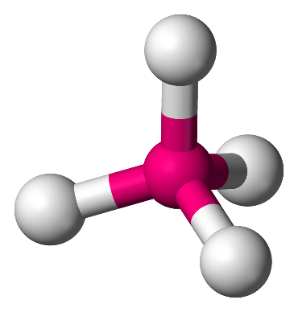
Tetrahedral Carbon Compounds
Tetrahedral bond angles = 109° degrees
This happen when the carbon has 4 single bonds
There are 3 types of tetrahedral carbon compounds on our course:
- Alkanes
- Alcohols
- Chloroalkanes

Alkanes
- Shape: tetrahedral - never planar.
- C-C functional group
- Bonds: All single bonds - saturated.
- General Formula: C_{n}H_{2n+2}
- Ending: -ane (eg: propane)

CH₄ - Methane |  | C₂H₆ - Ethane |  | C₃H₈ - Propane
H |  | H H |  | H H H
| |  | | | |  | | | |
H -- C -- H |  | H -- C -- C -- H |  | H -- C -- C -- C -- H
| |  | | | |  | | | |
H |  | H H |  | H H H

- They are saturated. This means that they undergo substitution reactions. This will be described later (free radical substitution and saponification).
- It is important to remember 2,2,4 trimethylpentane or iso-octane and Cyclohexane as these are important in fuels.

Structural isomers are compounds with the same molecular formula but different structural formula. They differ in physical properties, e.g. boiling points. An example is Butane and Methylpropane

It is important to know the use of alkyl groups when asked to form an isomer. An alkyl group is an alkane molecule from which a hydrogen atom has been removed.
- CH₃ - methyl group
- C₂H₅ - ethyl group
- C₃H₇ - propyl group

Physical State:
Alkanes have low melting and boiling points. The symmetrical nature of the molecule makes them non-polar means and so they have weak van der walls intermolecular forces (which rely on temporary dipoles). As the chains get longer there are more electrons and more temporary dipoles (so stronger intermolecular forces) occur so the boiling pts increase with chain length.
Solubility: (Remember like dissolves like)
Alkanes are non-polar so are soluble in non-polar solvents such as cyclohexane but are insoluble in polar substances like water

Alcohols
A homologous series similar to alkanes but with a hydrogen replaced by an -OH (hydroxyl) group. The ending is -anol (eg: propanol). The general formula is C_{n}H_{(2n+1)}OH.
- -OH is the functional group. Called the Hydroxyl group.
- Remember - alcOHol
- General formula is C_{n}H_{(2n+1)}OH (alkyl + OH group)
- Alcohols are named by replacing the -ane from its corresponding alkane with -anol
- Primary Alcohol - Where the carbon atom joined to the -OH group is attached to only ONE other carbon atom. e.g. Ethanol & Methanol.
- Secondary Alcohol - Where the carbon atom joined to the -OH group is joined to
TWO other carbon atoms. e.g. propan-2-ol
- Tertiary Alcohol - Where the carbon atom joined to the -OH group is joined to THREE other carbon atoms. e.g. 2methylpropan-2-ol.
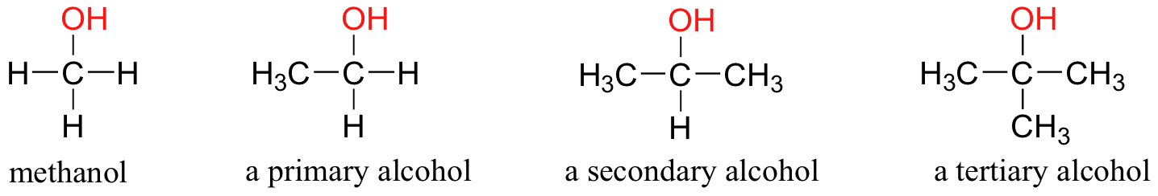
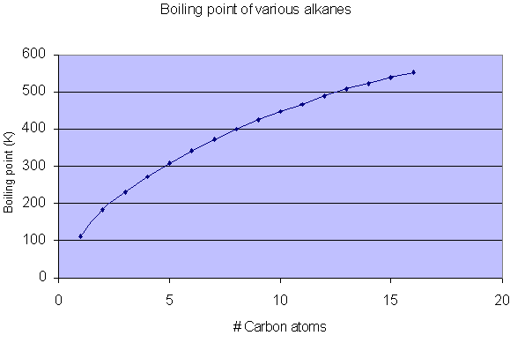
*Always indicate/prioritise the position of the hydroxyl group when naming alcohols. For example 2methylbutan-1-ol which has a methyl group attached to the second carbon and the hydroxyl group is attached to the first carbon.

The hydroxyl group of the alcohols changes their chemistry drastically from their corresponding alkanes. In particular, it affects their boiling points and solubility.
Boiling Points:
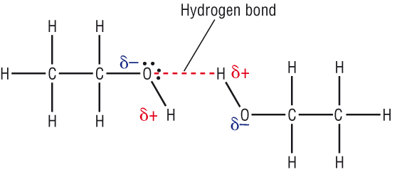
They have higher boiling points than their corresponding alkanes because of the highly polar -OH group giving rise to hydrogen bonding between alcohol molecules. Hydrogen bonds are stronger and require more energy to be broken.
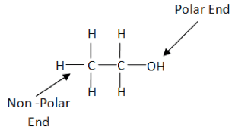
Solubility:
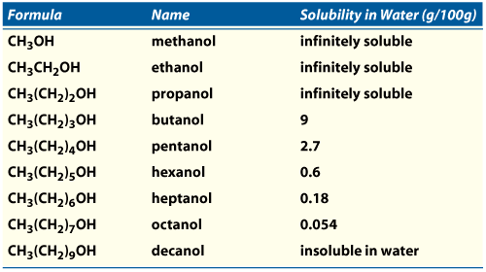
There are 2 parts to the alcohol molecule the alkyl part and the OH part. The OH group is highly polar and if the chain is short (like ethanol) it forces the non-polar carbon chain to dissolve in polar substances such as water. If the chain becomes too long the OH group can no longer force the chain to dissolve in polar substances so it dissolves in non-polar substances instead (cyclohexane). (Like dissolves like.)
The solubility changes as the length of the carbon chain increases. Solubility in water decreases with the length of the carbon chain because of the insoluble alkyl portion counteracts the polar OH group making it soluble.

Ethanol
- Ethanol found in alcoholic drinks is formed by fermentation, fruits with glucose have yeast added to them (catalyst=zymase), the sugar forms a solution of ethanol and carbon dioxide as a result. These kind of drinks like wine contain 10% - 12% v/v ethanol, once ethanol reaches this percentage it kills all of the yeast and fermentation stops. Therefore fermentation alone DOES NOT produce drinks greater than 12% v/v.
- To increase alcohol concentration, fermented liquids are distilled. Wine is distilled to brandy. The distilling industry produces spirits like vodka, brandy, tequila, gin and whiskey.
- Uses of ethanol: alcoholic drink (consumption), fuel, solvent (such as perfumes, dyes, varnishes etc...).
- It is a good solvent because of hydrogen bonding.

Chloroalkanes
- An alkane with one or more of it’s hydrogens replaced by chlorines.
- Shape: tetrahedral - never planar.
- Bonds: All single bonds - saturated.
- Ending: Chloro-ane (eg: chloropropane)
- If there are two chlorines it’s di-chloro-ane, if there are three chlorines it’s tri-chloro-ane, if there are four chlorines it’s tetra-chloro-ane.

CH₃Cl - Chloromethane C₃H₅Cl₃ - 1,1,2-triChloropropane
Cl H Cl H H Cl
| | | | | |
H -- C -- H H -- C -- C -- H H -- C -- C -- C -- Cl
| | | | | |
H H Cl H Cl H
C₂H₄Cl₂ - 1,1-diChloroethane

- They are mainly used for removing oil and grease marks from machinery, in dry cleaning and chloroform was used as an anaesthetic.
- They aren’t soluble in water but are soluble in non polar solvents such as cyclohexane. They also have low boiling points. (same explanation as alkanes)
- Rarely found naturally occuring.

Planar Carbon Compounds:
- Alkenes - C = C
- Alkynes - C triple bond C
- Aldehydes - RCHO
- Ketones - RCOO
- Carboxylic Acids - RCOOH
- Esters - RCOOR’
- Aromatic Compounds
Alkenes
- Shape: both tetrahedral and planar - tetrahedral everywhere but where the double bond is.
- Bonds: Unsaturated - contains a double bond undergo addition reactions.
- General Formula: C_{n}H_{2n}
- Ending: -ene (eg: propene)
- Only need to know Ethene, Propene, Butene.
C₂H₄ - Ethene |  | C₃H₆ - Propene |  | C₄H₈ - Butene
 |  | H |  | H H
 |  | | |  | | |
H -- C = C -- H |  | H -- C = C -- C -- H |  | H -- C = C -- C -- C -- H
| | | | | | | | |
H H H H H H H H H

- Ethene is the starting material from which many substances are made. e.g. Polythene, PVC, Polystyrene, synthetic rubber etc...Also used to ripen fruit commercially.
- Note: Ethene is prepared by dehydrating ethanol, a primary alcohol. The dehydrating agent is Aluminium oxide. This is explained later.

Physical State: (similar to alkanes)
Alkenes have low melting and boiling points. The symmetrical nature of the molecule makes them non-polar means and so they have weak van der walls intermolecular forces (which rely on temporary dipoles). As the chains get longer there are more electrons and more temporary dipoles (so stronger intermolecular forces) occur so the boiling pts increase with chain length.
Solubility: (similar to alkanes) (Remember like dissolves like)
Alkenes are non-polar (due to their symmetrical shape) so are soluble in non-polar solvents such as cyclohexane but are insoluble in polar substances like water

Alkynes
- Shape: both tetrahedral and planar - tetrahedral everywhere but where the triple bond is.
- Bonds: Unsaturated - contains a triple bond.
- General Formula: C_{n}H_{2n-2}
- Ending: -yne (eg: propyne)

C₃H₄ - Propyne C₄H₆ - Butyne
H H H
| | |
H -- C ≡ C -- C -- H H -- C ≡ C -- C -- C -- H
| | |
H H H
- Contain carbon carbon triple bonds and are highly unsaturated.
- Replace -ane with -yne
- Ethyne or Acetylene is used as Oxyacetylene in fire extinguishers, welding and cutting.
- Water and calcium carbide form ethyne, however bubble through copper sulfate solution to get rid of impurities like phosphine, ammonia and hydrogen sulfide gas.

Physical State (same as corresponding alkanes):
Alkynes have low melting and boiling points. The symmetrical nature of the molecule makes them non-polar means and so they have weak van der walls intermolecular forces (which rely on temporary dipoles). As the chains get longer there are more electrons and more temporary dipoles (so stronger intermolecular forces) occur so the boiling pts increase with chain length.

Solubility (same as corresponding alkanes): (Remember like dissolves like)
Alkynes are non-polar so are soluble in non-polar solvents such as cyclohexane but are insoluble in polar substances like water

Aldehydes and Ketones
Aldehydes and Ketones both contain the functional group C=O (carbonyl). However, in aldehydes it is positioned at the end of the carbon chain and in ketones it is positioned in the middle. The carbonyl group for aldehydes is sometimes written as C=OH or CHO as it’s at the end of a chain there is a hydrogen as well.

The ending for aldehydes is -anal (eg: propanal) and for ketones it’s -anone (eg: propanone).

The addition of the carbonyl group affects the boiling points and solubility of the aldehydes and ketones similarly. i.e. corresponding aldehydes and ketone have similar boiling points and solubility.

Boiling Point (ketone and aldehydes)
As the carbonyl group is highly polar aldehydes/ketone contains dipole-dipole intermolecular forces they have a higher boiling point than their corresponding alkanes which are non-polar (van der walls), but they a lower boiling point then their corresponding alcohols because of the lack of hydrogen bonding between aldehyde/ ketone molecules.
Solubility (ketone and aldehydes)
The first few aldehydes and ketones are soluble in water (polar) and the rest are soluble in cyclohexane (non-polar) as the dipole-dipole forces from the C=O part can only force a few carbons to dissolve in a polar substance.
- Solubility in water of aldehydes/ketones decreases as the length of the carbon chain increases due to the portion of the non-polar alkyl molecules.
- Lower members of aldehydes/ketones are highly soluble in water because the O of the carbonyl group can form a hydrogen bond with the H of the water molecule.
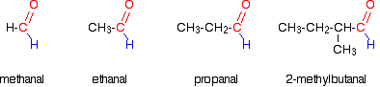

Aldehyde
- Functional group is -CHO where C and O is a double bond.
- General formula is R-CHO (R=Carbon group)
- Aliphatic Aldehydes are C_{n}H_{(2n+1)}CHO.
- -ane is replaced by -anal.
- Remember; methanal, propanal, ethanal and butanal or 2-methylpropanal.
- Most aldehydes are liquid at room temperature but methanal is gas.
- Methanal in water is called Formaldehyde and is used as embalming fluid and to preserve biological specimens.
- Benzaldehyde is found in the oil of almonds.

Tests for aldehydes
- Aldehydes reduce Cu²⁺ ions to Cu⁺ ions, goes from blue to brick red in Fehlings Solution.
(Fehling’s A = copper sulfate in water and Fehling’s B = potassium sodium tartrate)
- Aldehydes reduce Mn⁷⁺ ions to Mn²⁺ ions, goes from purple to colourless in Potassium Manganate (VII).
- They reduce Ag₊ silver ions in dilute ammonia to silver metal

Ketones
- Functional group is the C=O group attached to 2 carbon groups represented by R
- General formula is RCOR’
- First Ketone is Propanone
- -ane is replaced by -anone
- The only difference between aldehydes and ketones is that the hydrogen atom in aldehydes is replaced by an alkyl/carbon group.
- Propanone and Butanone only.
- Propanone is also called acetone - organic solvent such as nail varnish remover.

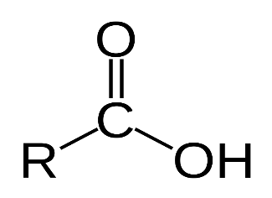
Carboxylic Acids
Functional group -COOH
General formula is RCOOH (where R represents a carbon group)
- Has both C=O group (like aldehydes) and C-OH group (like alcohols) bonds.
- ending for Carboxylic acids is -anoic acid (eg: propanoic acid).
- Methanoic acid - stings of nettles and ants,
- Ethanoic acid - vinegar, cellulose acetate (photographic film and lacquers)
- Propanoic, benzoic and some of their salts preserve foods
- Butanoic acids - unwashed socks
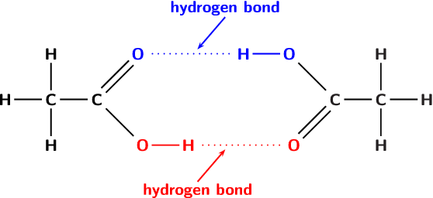
Boiling Points:
Hydrogen bonding occurs between molecules of carboxylic acids. In fact 2 H-bond are formed between neighbouring carboxylic acids.
They have a higher boiling point (i.e. it takes a lot of energy to break them) than their corresponding alcohol due to there being
more hydrogen bonding between carboxylic acids than alcohols.
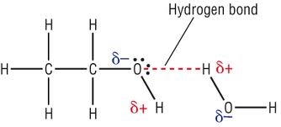
Solubility:
- Lower members are highly soluble in water due to the carboxylic acid group forming hydrogen bonds with water molecule.
- The solubility of carboxylic acids in water decreases with length of carbon chain due to the insoluble alkyl portion of the molecule.
- Quite soluble in organic solvents.

Pure ethanoic acid is liquid at room temperature but if it falls below 17 degrees it becomes solid (Glacial acetic acid) because of increased hydrogen bonding and clusters of dimers (groups of 2 molecules joined together) held together by H bonding.

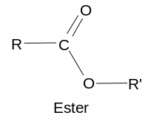
Esters
-COO- functional group
- RCOOR’ general formula
- Derived from carboxylic acids by replacing H of OH group with an alkyl group.
- replace e in -ane with -oate
- Formed by reaction of alcohol and carboxylic acid. - Condensation reaction as it loses a water molecule.
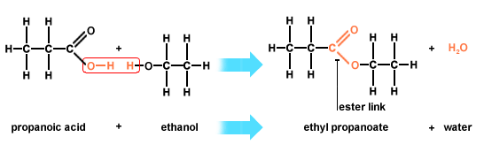
- Take note of naming. Start with the alkyl group from the alcohol and THEN with the carboxylic acid, changing the -oic to -oate. e.g. methylethanoate
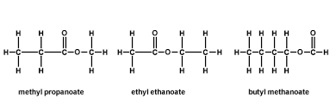
Ethyl Butanoate
- Esters are volatile liquids with pleasant fruity smells
- Fats and oils are naturally occurring esters from alcohol (glycerol) and long chain fatty acids.
- Ethyl ethanoate is made by heating ethanol, glacial ethanoic acid and a few drops of concentrated sulfuric acid. It is used as a solvent in many glues.

Boiling points:
- Low boiling points because hydrogen bonding is not possible between ester molecules.
Solubility:
- Lower members are soluble in water as they can form hydrogen bonds with water.
- Solubility decreases as length of carbon chain increases due to (non-polar) alkyl portion.
- Soluble in organic solvents.
Aromatic Compounds
- Contain a benzene ring structure in their molecules.
- All of the bonds in a benzene ring are identical and are intermediate between double and single bonds.
Each carbon atom in a benzene ring has 4 electrons in its outer shell. 3 of these electrons form sigma bonds. 2 of these three sigma bonds are formed between the carbon atom and the 2 adjacent carbon atoms. The third one is formed between the carbon atom and the hydrogen atom.
- The one electron remaining is in a P orbital. Each P orbital overlaps sideways with its neighbouring 2 P orbitals to form 2 doughnut shaped electron clouds. These 2 electron clouds constitute a single pi bond in the benzene molecule.
- The delocalised clouds of electrons help to bind together the 6 carbon atoms and give extra stability to the benzene molecuke, therefore it does not undergo the typical addition reactions that C=C compounds go through.
- It is non polar and widely used as an organic solvent. It is also very carcinogenic.
Methylbenzene or toluene is its substitute and used as an industrial solvent, manufactures plastics and explosives and added to petrol to increase octane ratings.

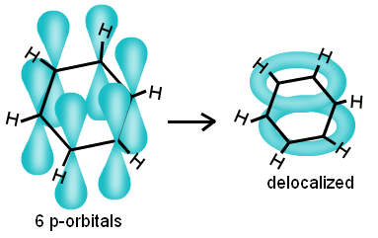
- Aromatic compounds are widely used as the basis of pharmaceutical compounds in making insecticides, disinfectants, herbicides, dyes, detergents, acid base indicators (methyl orange and phenolphthalein)

Organic Natural Products
Organic compounds that are found in nature include; Benzaldehyde, Caffeine, Nicotine, Opium,
Penicillin.
- Important that these can be synthesized in the laboratory because they may otherwise be difficult to obtain due to seasonal nature of plants etc...
- Mostly isolated for medicinal purposes, others for perfumes (fragrant oils) etc...
- Steam Distillation separates oils from the plants themselves.
- Involves carrying out a distillation through a current of steam, it is important that the temperature isn’t too high as it may harm the plant material.
- The mixture of steam and oil distils below the boiling point of water and below that of the plant and its oils.
- The mixture of oil and steam is then condensed by passing it through a Liebeg condenser. It is then allowed stand and the 2 mixtures are separated from each other using a separating funnel.
- Emulsion is when the distillate comes over as oil droplets dispersed throughout water. i.e. the organic solvent dissolves the oil but doesn’t mix with water added to the emulsion and shaken with it. The organic solvent is allowed to evaporate leaving the pure oil behind - this is called solvent extraction.

Reactions in Organic Chemistry
- Substitution Reactions
- Additions Reactions
- Elimination Reactions
- Redox Reactions
- Reactions as Acids

Substitution Reactions
A substitution reaction is a chemical reaction in which an atom or group of atoms in a molecule is replaced by another atom or group of atoms.

The Mechanism of the reaction is a detailed step by step description of how the overall reaction occurs.
Substitution
Halogenation of Alkanes
I. Initiation
A chlorine molecule is broken down into two chlorine atoms in the presence of UV light. The bond breaks in such a way that each atom joined by the bond retains 1 of the 2 electrons in the bond. This is called heterolytic fission.
This is a photochemical reaction, i.e. a reaction brought about by light.
Evidence for this is that the same reaction will not occur in a dark room but takes place rapidly in UV light.

- Propagation
In this step a chlorine atom attacks a methane molecule to form hydrogen chloride and a species called a methyl free radical. A free radical is any atom or group of atoms with an unpaired electron. They are very reactive and only exist for short periods of time, responsible for the process of ageing.

- Propagation
In this step a methyl free radical attacks a chlorine molecule to form chloromethane. This sets up a chain reaction as the chlorine molecule produced here can react with another molecule of methane.
Propagation keeps the chain reaction in operation to generate chloromethane.

Evidence - Amount of light absorbed in a glass container, for every photon absorbed there are thousands of molecules of chloromethane produced.

- Termination
The chain reactions can go through hundreds and thousands of cycles before termination occurs. They are fast and explosive in nature.
A number of reactions take place to stop the chain reaction, all of these involve free radicals or atoms combining with each other, causes the chain reaction to end.
- Cl + Cl = Cl₂ chlorine
- CL + CH₃ = CH₃Cl chloromethane
- CH₃ + CH₃ = C₂H₆ ethane

Evidence - comes from the fact that small amounts of ethane are found among the products of combining free radicals.

This is called free radical substitution reaction.
e.g. Add some bromine water to cyclohexane, cyclohexane is less dense than water so it will form an upper layer, under UV light a reaction occurs between cyclohexane and bromine but has no effect on the bromine water.

Halogenated Alkanes are useful for making flame retardants / materials less likely to catch fire. They used to be used in fire extinguishers which was denser than air and didn’t support combustion.

Esterification
Esters are formed when a carboxylic acid and alcohol react, this condensation reaction can also be called a substitution reaction. The H in the -OH group of carboxylic acid is replaced by an alkyl group.
Esterification is an equilibrium reaction, ester formed reacts with water to form carboxylic acid and alcohol - the reverse = hydrolysis. Esters are hydrolysed effectively in presence of base like sodium hydroxide.
This results in the salt of the carboxylic acid rather than the acid itself however. Base Hydrolysis of Esters = Saponification

Addition Reactions
(ionic addition and polymerization)

1. Ionic Addition
Addition reaction is one in which two substances react together to form a single product/substance.

- The C = C region in ethene is an area of negative charge. The Br₂ molecule, as it approaches ethene, becomes polarised.
- The induced polarisation becomes so great that the Br₂ molecule splits in Br⁺ and Br⁻ species, 2 electrons end up on Br⁻ species, this is heterolytic fission.
- Br+ species needs to gain 2 electrons to have a stable octet outer shell. It therefore attacks, ethene or the C₂H₄ molecule. It forms a covalent bond with one carbon atom, the other carbon atom is left with a positive charge as it has lost an outer electron, this is the carbonium ion. - cyclic bromonium ion.
- The carbonium ion is then attacked by the Br- ion to form 1,2 dibromoethane.

Evidence - when ethene reacts with Bromine in water in the presence of sodium chloride solution it forms - 1 bromo-2-chloroethane (carbonium attacked by CL- ion) and 2bromoethanol (when carbonium ion is attacked by water molecule) and 1,2 dibromoethane (carbonium attacked by Br⁻ ion).

- HCL, H⁺ attacks C = C bond then CL- ion attacks carbonium ion to form 1, chloroethane
- Cl2, Cl⁺ species attacks C=C bond then Cl- attacks carbonium to form 1,2-dichloroethae

- 2. Polymerization
Polymers are long chain molecules made by joining together many small molecules. The small molecules from which polymers are made from are called monomers. They are a repeating structure.

polythene - bags, bowls, plastic lunch boxes polypropene- toys, plastic beakers, jugs...

Polypropene and polythene are addition polymers because only one type of monomer is involved and they are manufactured by addition reactions. These are the most important synthetic polymers.

Elimination Reactions
One in which a small molecule is removed from a larger molecule to leave a double bond in the larger molecule
An example would be the dehydration or the removal of water from alcohol to form an alkene.

Redox Reactions
- Primary alcohols are oxidised to aldehydes and aldehydes are oxidised to carboxylic acids.
- Suitable oxidising agents are acidified sodium dichromate or Na2Cr2O7 or acidified potassium permangenate KMnO4.
- If the oxidising agent is in excess the aldehyde will oxidise into a carboxylic acid. oxidation = dehydrogenation - removal of hydrogen.

- If a secondary alcohol is oxidised it goes to a Ketone.

- Oxidation of ethanol to ethanal: oxidising agent is sodium dichromate and the catalyst is sulfuric acid or H2SO4, chromium goes from +6 to +3/orange to green, use excess ethanol rather than excess dichromate and distilling off the ethanal to ethanal ensures that it is not further oxidised to ethanoic acid. i.e. further oxidation kept to a minimum.
- Reflux titration and excess sodium dichromate is used when oxidising ethanol to ethanoic acid. The sodium dichromate is in a flask here to ensure complete oxidation of ethanol to ethanoic acid. It is NOT in the funnel as above to make ethanal.

Reactions as Acids
Alcohols and Sodium - salt and hydrogen gas sodium and ethanol for sodium ethoxide and Hydrogen.
Why do carboxylic acids act as acids?
- Inductive effect
The carbon atom in the carboxyl -C-O-H- part of the group is slightly positive and attracts electrons from Oxygen atom of -OH group. The electron pulling effect = the inductive effect. Thus, the carbonyl group draws electrons away from the hydroxyl group and facilitates the ionisation of the H atom, therefore a carboxylic acid loses the proton of the COOH group quite readily - acidic properties.

- Stability of Carboxylate ion
When the carboxyl group loses a proton it forms the negatively charged Carboxylate ion. It is a resonance hybrid of two possible structures, either double or single bonds, the charge is spread evenly over the 3 atoms. This satbilisation by hybrid resonance drives the carboxylic acid to lose a proton.

Organic Synthesis
Organic synthesis is the process of making organic compounds from simpler starting materials.
The new molecule being prepared is the target molecule.
Each step involves preparing a new compound from the previous compound, e.g. ethene - ethanol - ethanal - ethanoic acid.

e.g. Aspirin, Paracetamol
Organic synthesis involves bond breaking and bond making
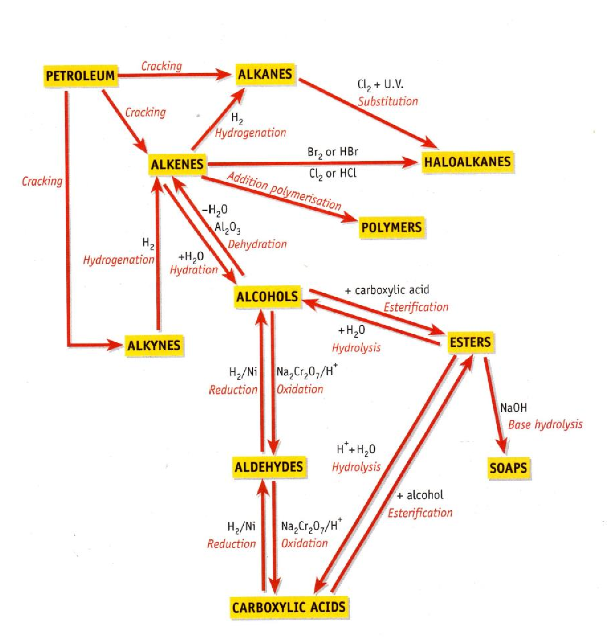

Chromatography is a separation technique in which a mobile phase carrying a mixture moves in contact with a selectively absorbent stationary phase.

Gas Chromatography -
The stationary phase is a high boiling point liquid spread on solid particles (alumina or silica gel) that are packed into a long coiled tube called a column. (i.e. in the tube)
The mobile phase is the gas
Alcohol level in blood, urine, drug tests etc...
The combined use of gas chromatography and mass spectrometry investigates the metabolism of drugs in the body and to detect the gases from waste dumps and organic pollutants in water.

High Performance Liquid Chromatography HPLC
Chromatography where a pump is used to pass a liquid through a tightly packed column
i.e. A mixture moves in contact with a selectively absorbent stationary phase, the mixture being the mobile phase.
Used in chemistry to separate different substances in a mixture and identify and measure amounts of these substances present in the mixture.
Substance being analysed is added to a liquid solvent which is passed over a solid.
A pump forces liquid through a narrow column/ tightly packed column.
Since separation is more efficient in HPLC the pump need not be as long as GC.
Used in analysis of food e.g. test for growth promoters in meat, vitamins and additives in food.

Infra red spectrometry (IR)
- organic compounds absorb infra red radiation by the vibrations of molecules.
- Every organic compound has a unique IR spectrum that serves as a finger print for it.
- Chemists can identify particular functional groups by studying the IR spectrum of a
compound
- Identifies plastics, illegal drugs, etc..

Ultra-Violet Spectrometry UV)
- Detects presence of functional groups in molecules by measuring the amount of UV light absorbed by the substance
- May also measure concentration of certain organic compounds in solution eg. Plant pigments, drugs etc...
- Maximum absorption tends to occur at a particular wave length. This helps to identify the compound and measure the concentration of the compound in solution.

