2011
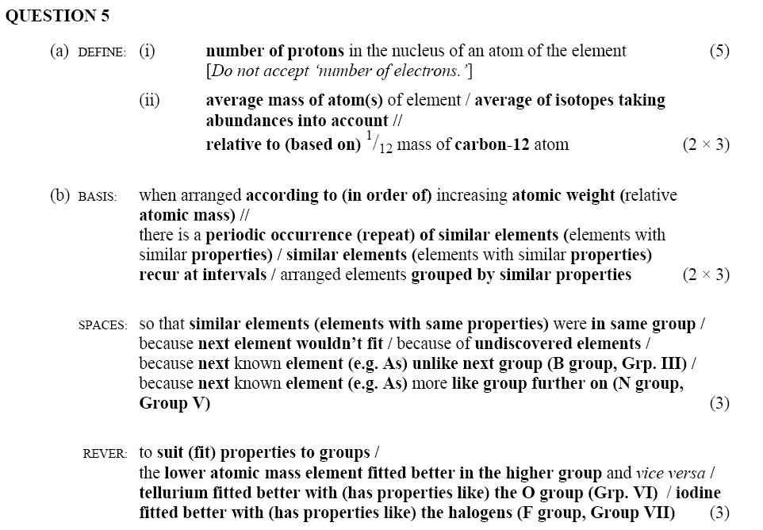
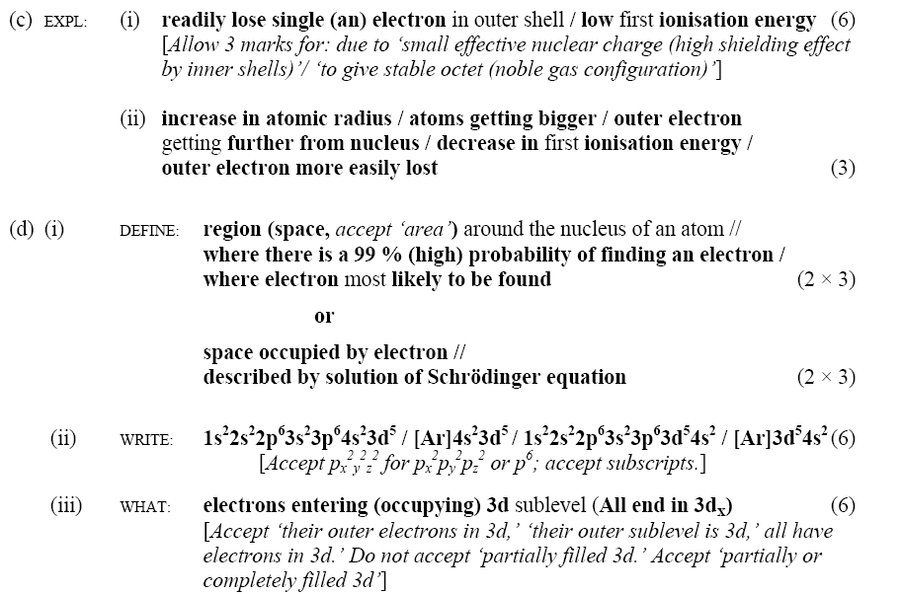
2012 Q4
(a) STATE: (i) 5, (ii) 9 (2 × 3)
(c) DEFINE: average mass of atom(s) of element / average of isotopes taking abundances into account // relative to (based on) 1/12 the mass of a carbon-12 atom (2 × 3)
Q5
Q11 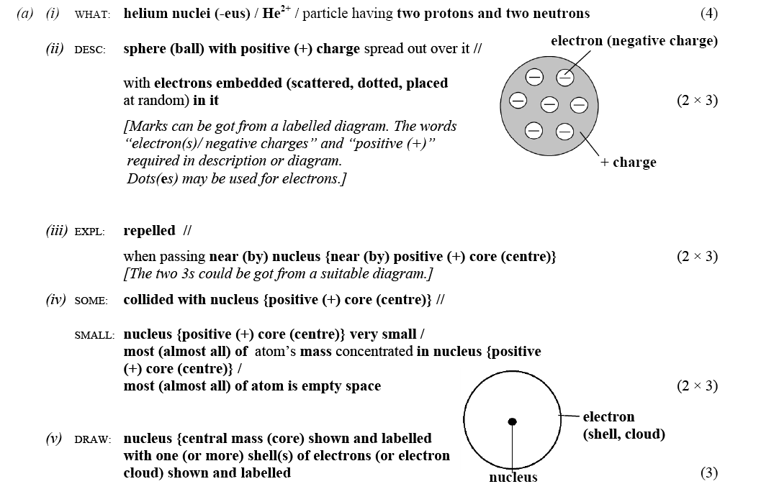
2010 Q4
Q5 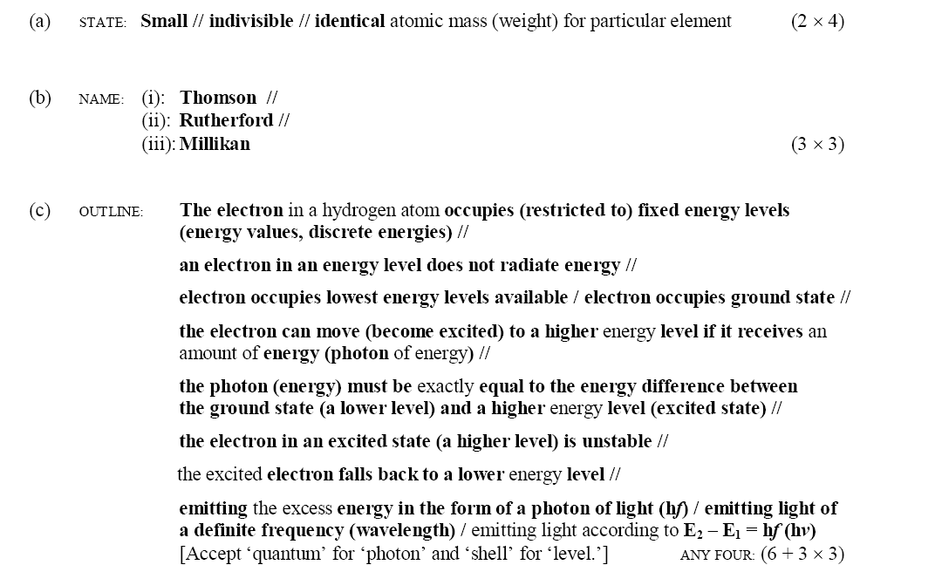 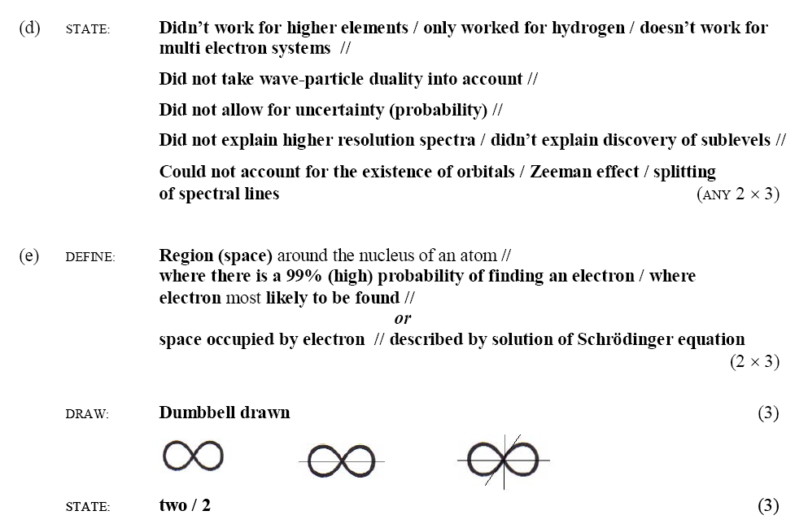
2009 Q4
(a) NAME: Robert Millikan (3) PARTICLE: electron (3)
(c) STATE: not possible to measure the exact position (location) and momentum (energy, velocity) of electron (3)
in atom simultaneously (at same time) (3)

Q5

2008 Q4 (a) 1s²2s²2p⁶ / [1s²2s²2p⁶]³⁺ / [He] 2s²2p⁶ (6)

(b) characteristic positive charge for element / atomic number / number of protons in nucleus (6)
[Accept “arranged in increasing atomic number”.]

(c) positive (+) charge (attracted to negative) // mass 4 // relatively low velocity (speed) // poor penetration (high absorption, stopped by skin, stopped by few sheet(s) of paper, stopped by few cm of air) // strong ionisation //stable nucleus // gains two electrons to form helium atom // damages cells (causes cancer) // deflected by electric fields // deflected by magnetic fields // causes luminescence (fluorescence, phosphorescence) ANY TWO: (2 ×3)
[Accept “low energy” in place of “low velocity”. Do not accept “helium nucleus” or “2 protons + 2 neutrons”.]

Q10
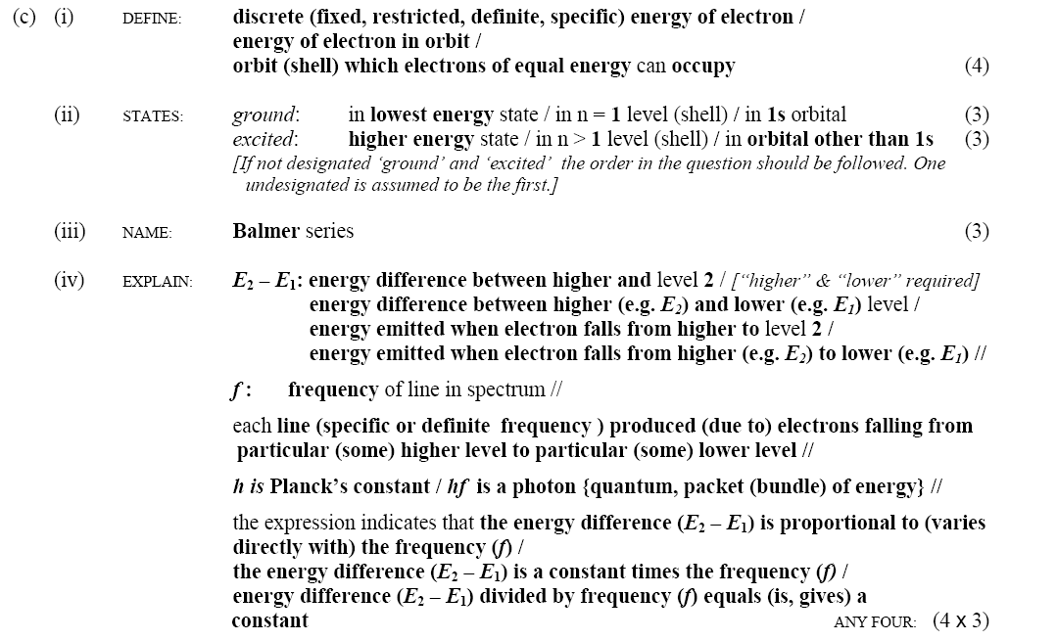
2007 Q5 (a) DEFINE: discrete (fixed, restricted, definite, specific) energy of electron /energy of electron in orbit / orbit (shell) which electrons of equal energy can occupy (5)
Q11

